| FORENAME SURNAME | DESIRED JOB TITLE Location  email@example.com  +123 456 7890 |
| --- | --- |
|  | |
| PROFESSIONAL SUMMARY | Here, clearly explain your motivation for changing careers and highlight the key transferable skills you've gained from previous roles that relate directly to your new industry. Mention any recent courses, qualifications, voluntary work, or personal projects you've undertaken that demonstrate your readiness for your new career path. Avoid going into too much detail about your previous sector - focus instead on showing recruiters how your existing experience uniquely positions you to succeed in your new field. |
|  |  |
| CORE SKILLS | 6 – 8 short bullet points • Highlight most relevant transferable skills • Highlight important skills you’ve learned through training • Example • Example • Example |
|  |  |
| CAREER SUMMARY | Role Title, COMPANYMMM YYYY – PRESENT/DATE Outline  Provide a brief overview of the role, clearly highlighting responsibilities that demonstrate transferable skills relevant to your new career. Keep it short—just 1–3 lines are enough.  Key Responsibilities   * List your responsibilities, focusing on tasks or duties that showcase skills transferable to your new career. * Use professional language and frame your responsibilities in a way that demonstrates relevance to your new field. * Provide greater detail for recent or particularly relevant roles, and be more concise with older or less applicable experiences.   Key Achievements   * Highlight achievements that demonstrate your capability, particularly emphasising accomplishments relevant to your new sector. * Wherever possible, quantify achievements with clear, measurable outcomes (e.g. sold 1000 units in 1 month). |
|  |  |
| EDUCATION | QUALIFICATIONSCHOOL/BODY | MMM YYYY – PRESENT/DATE Prioritise any related training you’ve completed for the new field, expanding on specific modules that were particularly helpful. |

| ADDITIONAL INFO | Include relevant side projects, volunteering, hobbies, awards, languages, or memberships here to further showcase your suitability for your new career. Keep it brief, targeted, and impactful. |
| --- | --- |

**Need some more help writing your CV?**

**Check out the following resources on our site…**

* [**CV example library**](https://standout-cv.com/blogs/cv-writing-advice-blog/115702276-example-of-a-good-cv) - 100’s of real-life winning CV examples
* [**How to write a CV**](https://standout-cv.com/pages/how-to-write-a-cv)- The ultimate guide to writing an effective CV
* [**CV builder**](https://cvbuilder.standout-cv.com/cv-template-picker/) - Create a winning CV in minutes using unbreakable templates, pre-written content, and step-by-step expert guidance.

[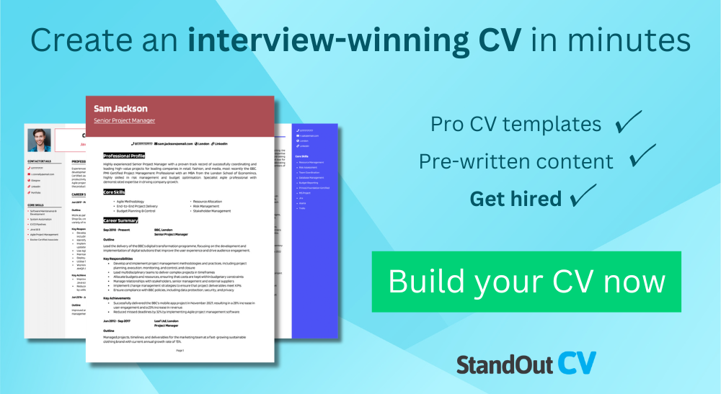](https://cvbuilder.standout-cv.com/cv-template-picker/)